**WAGNER—**Letter F – G

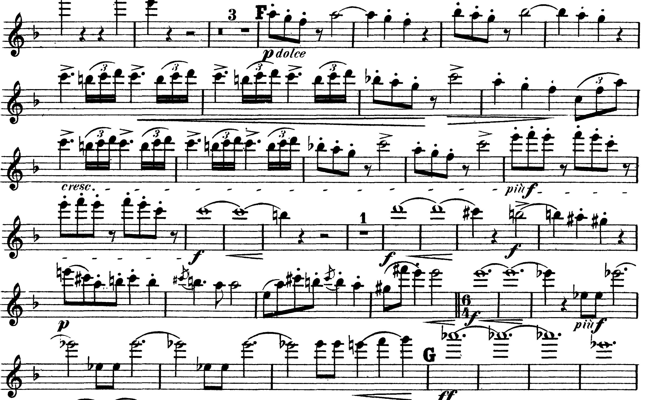

Letter L – *piano* *dolce*

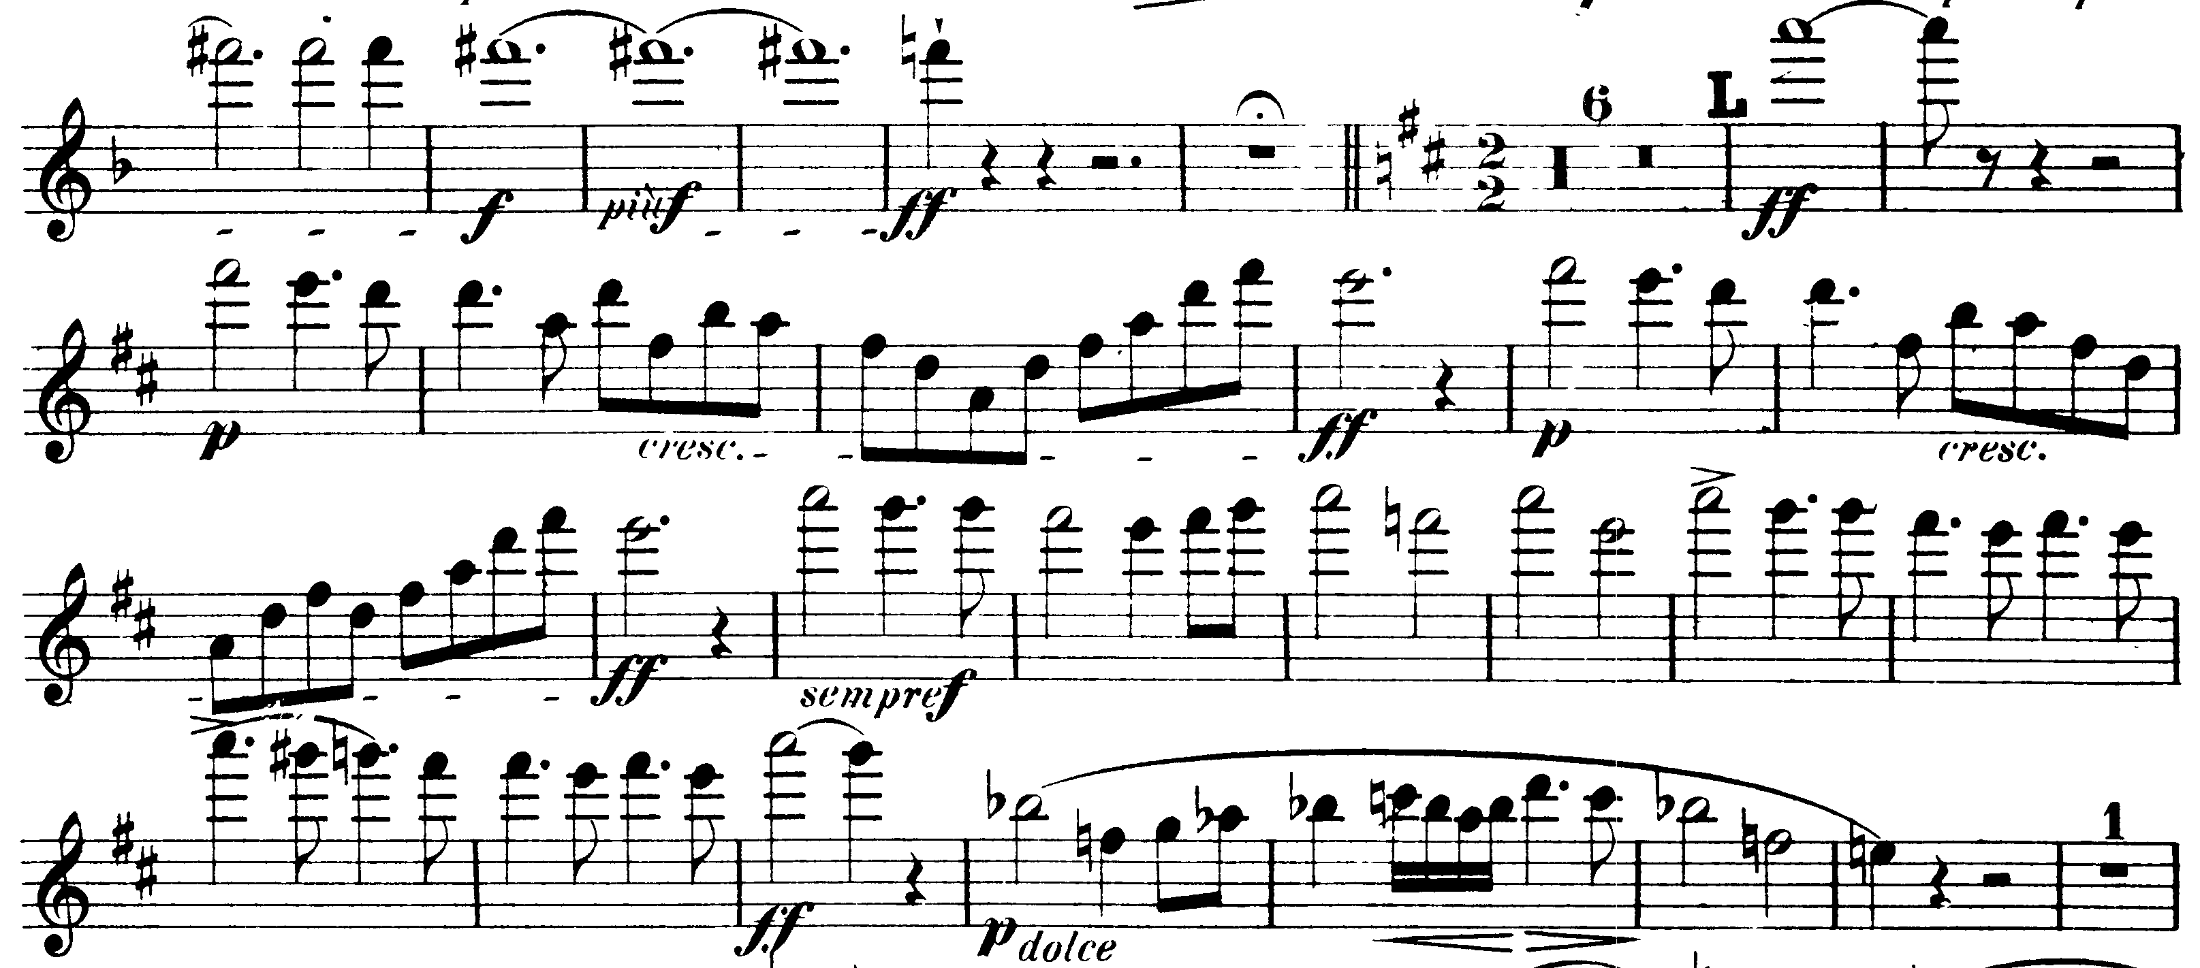

**TCHAIKOVSKY—**Mvt I: M – 266

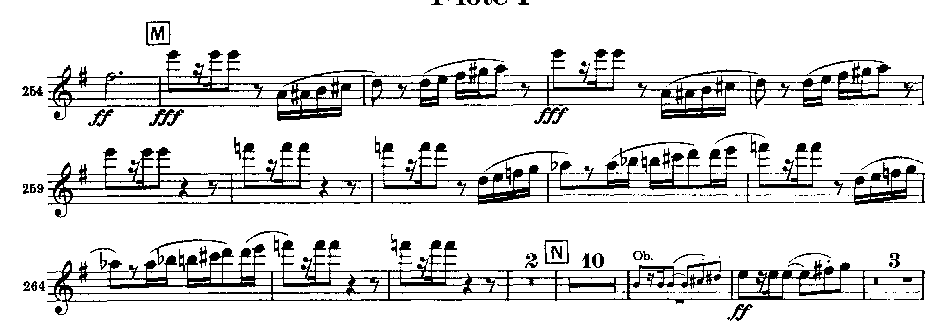

Mvt II: Andante mosso – Allegro non troppo

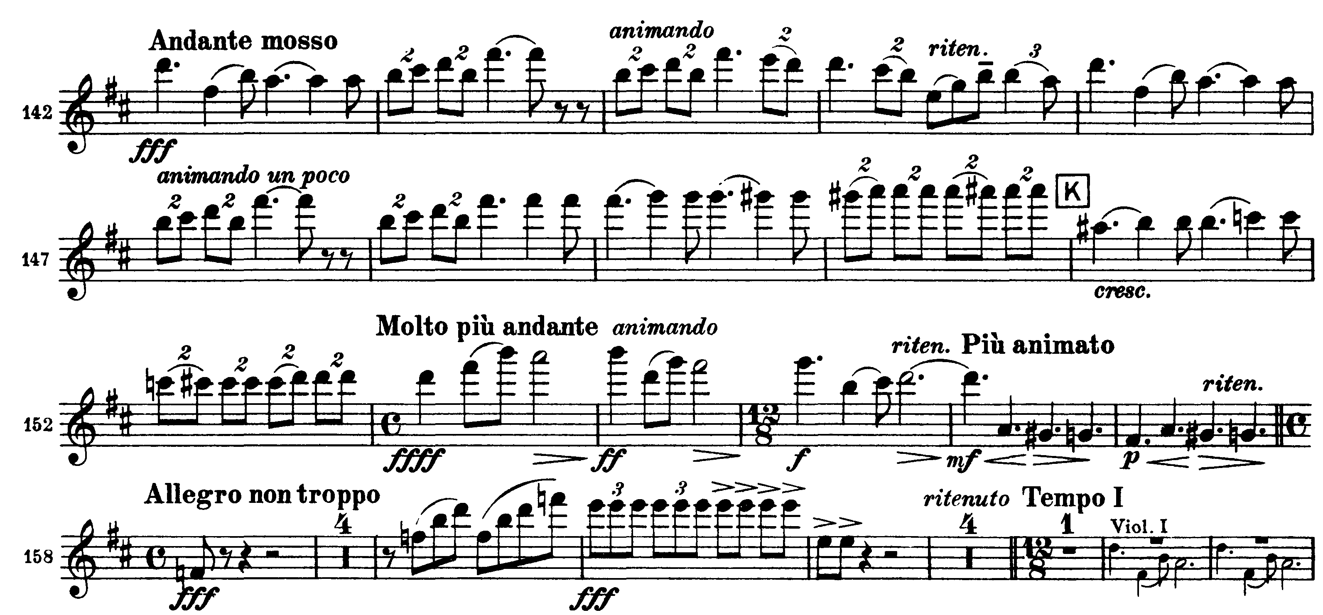

Mvt III: F – G (Flute & Picc)

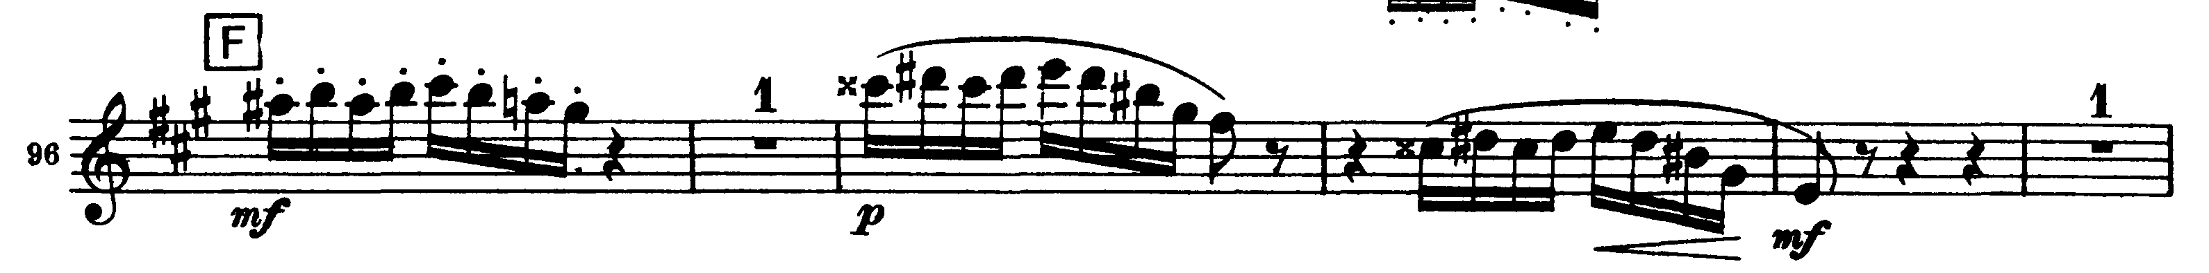

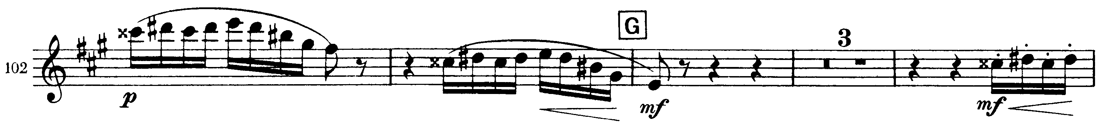

Mvt IV: Pick-up to Aa – Molto meno mosso

